**Introduction**

Our report will look at the products of competitors and distinguish our systems from theirs. We will use a variety of different search engines and searches to find our potential competitors, identify what their services offer, and give hypothetical features that our product will deliver that theirs won’t.

**How the Survey was Conducted**

When looking for our competitors, we used Google, Microsoft Edge, the Apple App Store, and the Google Play Store. There, we used keywords like “weather application”, “traveling weather”, “severe weather”, etc. Through our searches, we found a variety of apps and websites, but four stood out: “Weather” from the Apple App Store, Google’s “Weather” app, “AccuWeather” app and website, and “The Weather Channel” app and website.

**Existing Systems**

Each of these has their own distinct features, but here are some that are common between all of them:

AccuWeather app/website

* Displays radar for the united states for the next 48 hours with a colored key table showing rain,snow, ice, and mix
* Has all the states in America’s weather conditions at the current hour, giving a picture of if it's sunny, rainy or cloudy and the temperature with it in fahrenheit.
* Has weather stories to help gauge upcoming weather phenomena
* Has a severe weather and hurricane tracker
* A tab for the windflow as well

Carrot Weather Application:

* Phone widgets you can add to your home or lock screen to show the current weather conditions
* UI that adapts to the weather so you know instantly what weather it is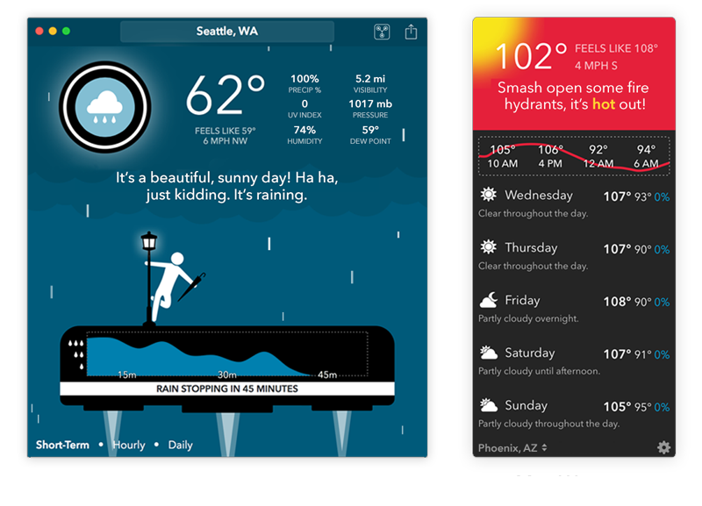
* Forecast for the upcoming 7 days
* Storm map with color coding
* There is an interface maker where you can add, remove, and change spacing between and customize components that appear on the weather forecast
* Displays location lists with temperature, air quality, wind flow, and precipitation.
* Has a chat gpt based chat bot that allows users to chat directly with the apps personality that you can change in the settings
* Achievement system where you can unlock them by experiencing weather events, traveling around the world, and using different features on the application.

The Weather Channel Mobile App:

* Displays Temperature, Humidity, Wind, Cloudiness, Chance of Rain, and their predicted values for the next 48 hours at your current location.
* Displays current location geographically on an interactive radar map.
* Colors an entire region (green for rain, purple for hail, teal for snow) depending on the weather.
* Receive alerts about severe weather near your area.
* Displays sunrise and sunset times.

Weather App (Apple):

* Displays real time weather information at your specific location for up to 48 hours.
* Displays an interactive radar precipitation map.
* Displays severe weather alerts near your area.
* Add multiple locations to a queue and display the temperature, humidity and chance of precipitation of all locations at the same time.
* Displays the current Air Quality.
* Displays sunrise and sunset times.

**Our System**

Our application not only includes the common features found in leading weather applications like AccuWeather, Carrot Weather, The Weather Channel Mobile App, and Apple's Weather App, but also introduces novel functionalities that set it apart. These are:

1. Route-Based Weather Updates:

Unlike standard weather apps focusing on specific locations, our system provides continuous weather updates along a defined travel route. For instance, if a user is traveling from Chicago to Milwaukee, they can receive real-time weather conditions for all significant points along this route.

1. Personalized Weather Journey Planning:

Our app allows users to plan their journey based on weather predictions, offering alternative routes or travel suggestions to avoid severe weather. This proactive planning tool is designed to enhance safety and convenience in travel.

1. Interactive Weather Maps with Advanced Mapping Libraries:

Our application uniquely integrates advanced mapping libraries to provide interactive, global weather maps. This feature allows users to not only view current weather conditions but also interactively explore weather patterns and forecasts globally, a functionality that enhances the user experience beyond the typical static weather displays found in most apps.

**Sources:**

**(Note: We downloaded the apps and thoroughly explored their functionalities to also provide information about their features).**

1. Apple. “Weather.” *App Store*, 10 May 2016, apps.apple.com/us/app/weather/id1069513131.
2. Interactive, The Weather Channel. “Weather - the Weather Channel.” *App Store*, 9 Nov. 2008, apps.apple.com/us/app/weather-the-weather-channel/id295646461.
3. Weatherbed, Jess. “Carrot Weather Update Introduces Snarky Chatbot Based on Chatgpt.” *The Verge*, The Verge, 15 Mar. 2023, www.theverge.com/2023/3/15/23641118/carrot-weather-app-update-chatgpt-chatbot-radar-notifications.
4. *Carrot Weather for IOS and Android*, www.meetcarrot.com/weather/. Accessed 10 Nov. 2023.